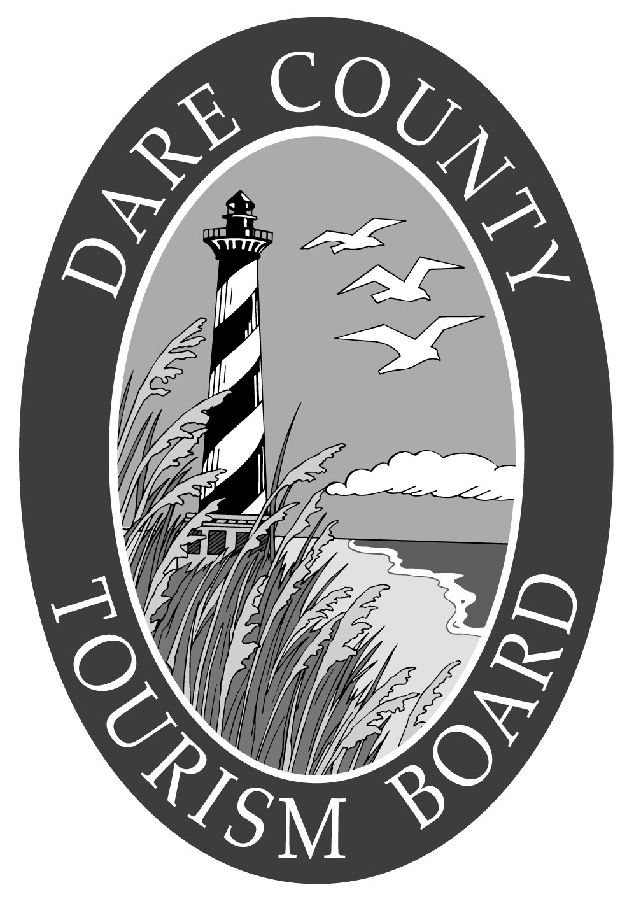
DARE COUNTY TOURISM BOARD
NATURAL CULTURAL HISTORIC FUND PROJECT APPLICATION

Name and title of person making application: _____________________________________

Local Government name: ____________________________________________________

Non Profit entity name: ______________________________________________________

If non-profit entity, you must enclose a copy of the written confirmation issued by the U.S. Internal Revenue Service conferring non-profit status under Section 501 of the U.S. Internal Revenue Code.

Principal place of business: ________________________________________________________

Address: ______________________________________________________________________

Phone number: _________________________________________________________________

1. Project Name and Location:
______________________________________________________________________________

______________________________________________________________________________

2. Amount of Grant Requested: ________________________________________________

Preliminary architectural, engineering, surveying and other forms of professional services, inkind services (ex. Administrative salaries of public employees) and any local, state or federal tax are not applicable.

Total Project Cost: ________________________________________________________

Amount the Applying Entity is Contributing (if any): _____________________________

3. Project Timeline (starting date and duration): ___________________________________

______________________________________________________________________________

4. Name of Property Owner and Mortgage-holders (if any):

______________________________________________________________________________

______________________________________________________________________________

5. Project goals and objectives: ______________________________________________________________________________

______________________________________________________________________________

______________________________________________________________________________

______________________________________________________________________________

6. Explain in detail how the proposed project meets the short/long term master plan for the applying municipality/organization (attach recent master plan approved by governing body).

______________________________________________________________________________

______________________________________________________________________________

______________________________________________________________________________

7. Project timetable (starting date and duration): ______________________________________________________________________________

______________________________________________________________________________

__________________________________________________________________________________________

____________________________________________________________________________________________________________

8. Project justification as relates to impact of tourism in Dare County (include an estimated return of investment for project funding):

________________________________________________________________________

________________________________________________________________________

________________________________________________________________________

9. Other information that may be helpful in considering the project (attach additional material as appropriate).

____________________________ ___________________________________
DATE SIGNATURE

