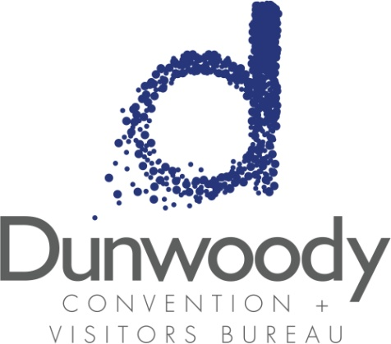

Fourth Quarter Board Meeting
October 20, 2016
11:30 a.m. – 1:00 p.m.
Meeting Agenda:

- Meeting Called to Order

- Minutes
- August 4 Board Meeting

- Committee Reports
  - Executive Michael Bryan
  - Personnel Nancy Musselwhite
  - Finance Bill Grant

- Director’s Report Katie Williams
Sales Report Steven Schumacher

- Old Business
  - 2017 Nominating Committee

- New Business
  - 2017 Budget Review and Approval
  - City of Dunwoody Development Authority Meeting
  - 2017 CVBD Annual Meeting

- Adjourn

