CRM Instructions
Updating Images and Video

http://extranet.denver.simpleviewcrm.com

Viewing Your Member Record
Depending on your access levels, there are various items that can be viewed under your Member Record:
- Web – Images and Video

Listing Images
To attach an image to your listing(s), click on the Web tab, and then the Media tab. If you have any images already uploaded you will see them there.

To add new images:
- Click on the “New Logo/Image” button on the right hand side of the screen
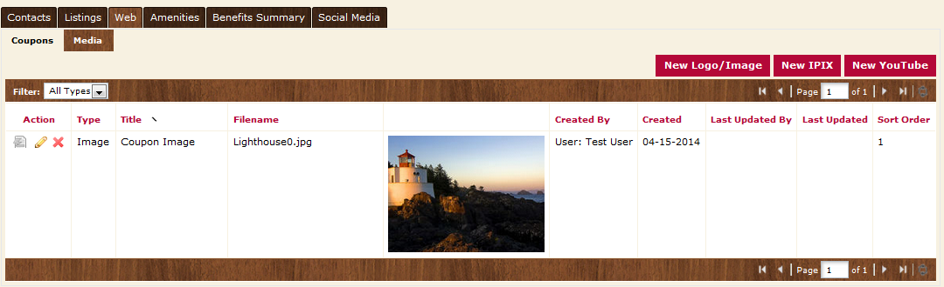

- For your main thumbnail, choose “logo” for type; for photo gallery images choose “image” for type
- Enter the Title of the photo you are uploading
- Browse to find the file on your computer
- Click the box to the left of the listings you would like the image to appear on (Publication Guide listings do not apply)
- Click save to save your image to your account

To add a new YouTube video:
- Click on the “New YouTube” button on the right hand side of the screen

- Enter the Title of the video you are uploading
- Enter the YouTube URL for your video without the “http://”. For example: Enter only www.youtube.com/watch?v=UY435zgRxHo
- Click the box to the left of the listings you would like the image to appear on (Publication Guide listings do not apply)
- Click save to save your YouTube video to your account

