Printing from Wi-Fi or Home
You will need will need to register to Papercut in order to print from Wi-Fi or home.
REGISTERING TO PAPERCUT
- To register you will need to visit: https://gll.annodata.co.uk

- The page will display as below:

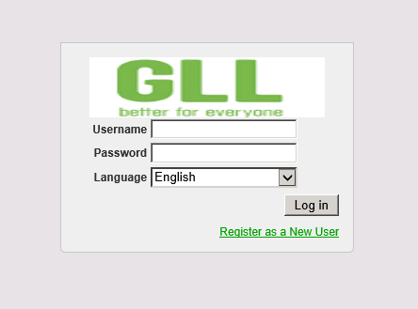
- Click on Register as a New User and enter your details.
- It is suggested that you use your library card number as your username and your PIN as a password, but you can choose any username and password if you prefer.
- An email notification with the account details will be sent to the e-mail address used during registration.
- The Identity Number that you will be given is the number that you will need to release your prints. The ID number can be found on the summary page by clicking on the word show
How to Logon after registration
- You will log in to Papercut with your chosen Username and Password when you wish to send documents to print
ADDING CREDIT
Papercut vouchers are brought in the same way as photocopier cards.
Credit is added to the account by clicking Redeem Card on the main menu and then typing the card number into the box and clicking the Redeem Card button.
PRINTING
- To start web printing, you will need to click on Web Print on the Papercut Homepage.
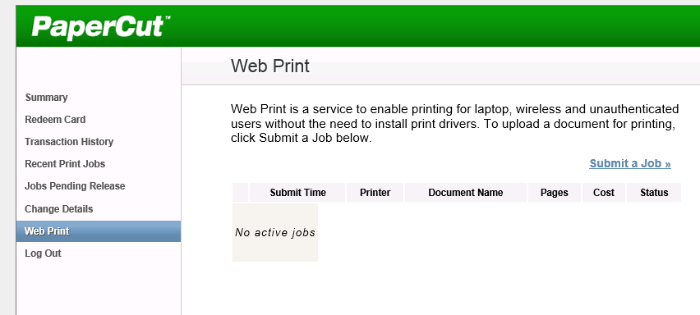
- Click on Submit a Job
- You will then be presented with a list of library printers to choose from.
- Once you have selected a printer and clicked Print options and account selection you will be asked how many copies you wish to print
- You will then need to click on Upload document
- File types that can be uploaded are: MS Word, Ms Excel, MS PowerPoint and Adobe PDF files.
- Once you have chosen the document you wish to print click Upload & Complete and the document will be put into the selected printer’s print queue.
Collecting Printouts
- If you have credit on your Papercut account to cover the print jobs you have queued then can to go to the printer in the library, and input your Identity number into the control panel

- This will then release the print job.
- If you do not have sufficient credit on your Papercut account you will need to purchase print vouchers from library staff, and redeem them on your account before following the above steps.

